CASE | ISSUE | AD(JR) | DISCUSSION
Entick v Carrington [1765] EWHC KB J98 | Principle of legality  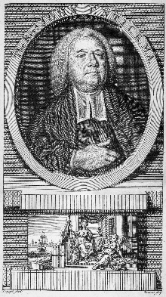  that requires legal authority for any action it undertakes. | Not relevant here (English Case).  Common law issue of Ultra Vires there was no right under statute or precedent to issue a warrant. | On 11 November 1762, the King's Messengers broke into the home of the Grub Street writer, John Entick (1703?-1773) in the parish of St Dunstan, Stepney "with force and arms". Over the course of four hours, they broke open locks and doors and searched all of the rooms before taking away 100 charts and 100 pamphlets, causing £2,000 of damage.  The King's messengers were acting on the orders of Lord Halifax, newly appointed Secretary of State for the Northern Department, "to make strict and diligent search for . . . the author, or one concerned in the writing of several weekly very seditious papers intitled, The Monitor, or British Freeholder".  Entick sued the messengers for trespassing on his land.  The trial took place in Westminster Hall presided over by Lord Camden, the Chief Justice of the Common Pleas. The messengers claimed that they acted on Halifax's warrant, which gave them legal authority to search Entick's home; they therefore could not be liable for the tort.  However, Camden held that Halifax had no right under statute or under precedent to issue such a warrant and therefore found in Entick's favour.  Lord Camden ruled, as later became viewed as a general principle, that the state may do nothing but that which is expressly authorised by law, while the individual may do anything but that which is forbidden by law.  This is one of the first cases to establish that government action which intrudes on individuals existing rights will be unlawful unless there is legal authority to support the action.
A v Hayden [1984] HC 67 | 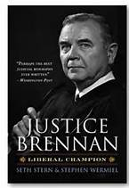  Principle of legality that requires legal authority for any action it undertakes. | Not strictly an AD(JR) Act matter, but based essentially on acting beyond the scope  prerogative. | The plaintiffs : -4 Australian Secret Intelligence Service Officers (ASIS)  6 Civilians under part time employment with ASIS  1 Army Rep  The Defendant: Commonwealth  The Plaintiffs participated in a security training exercise at the Sheraton Hotel in Melbourne which involved freeing a hostage from a hotel room using masks and carrying weapons.  The Victorian Government though this was a criminal activity and wanted the names of the participants from the Commonwealth Government in order to investigate the crimes and consider prosecution.  The Plaintiffs sought an injunction to prevent the release of their names on the grounds of:  - contract of employment confidentiality  - the training had ministerial approval  - carried out with ASIS instruction  - participants given “training cards” saying it was a commonwealth exercise.  HELD: Case held that the governments, even in their pursuit of national security objectives, do not inherently possess power to authorise their officials to act in defiance of the criminal law.  The executive power of the commonwealth must be exercised in accordance with the constitution and the laws of the commonwealth. The GG, the Federal Executive Council and every officer of the commonwealth are bound to observe the laws of the land. Constitutional writs are available to restrain apprehended violations and to remedy past violations. No agency of the Executive Government is beyond the rule of law.
Church of Scientology Inc v Woodward (1982) 43 ALR 587 | ASIO was conducting an investigation into the church.  Church contended that ASIO acting beyond the scope of its powers.  Can the doctrine of Ultra Vires apply to the activities of ASIO where the activities of ASIO exceed its statutory functions.  S. 17 of the Australian Security Intelligence Organisation Act 1979 (Cth) provided that ASIO’s functions were “to obtain, correlate and evaluate intelligence RELEVANT TO SECURITY”…”IN RESPCT OF MATTERS RELATING TO SECURITY”. | Not an AD(JR) matter but a common law matter on whether certain actions of parties are available for review on the ground that the actions were not permitted by the statute. | Court ruled that the judiciary can examine whether administrative action undertaken by a national security agency is supported by the legislation establishing the agency.    In this case the debate was about whether the issue was justiciable or not, not the actual hearing of the matter.
London County Council v Attorney General [1902] House of Lords | Power of statute to run a bus instead of a tram. | English Case | A number of private bus companies in London succeeded in challenging the council’s right to run bus services.  Held: Where the London County Council had statutory powers to purchase and operate tramways, it was held by the House of Lords that it had no power to run omnibuses, which was not incidental to the running of tramways.  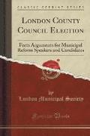
Vickers v Minister for Businesses and Consumer Affairs | 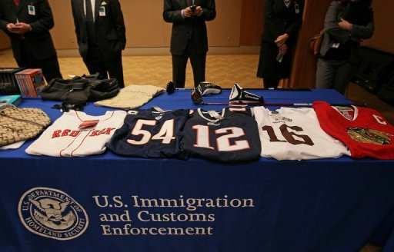  Whether money seized in a bank account exceeded powers of the Customs Act 1901 | AD(JR) Act applied, case heard in Federal Court. | A Federal Police Officer purporting to act under delegated authority from the Comptroller General of Customs seized bank notes to the value of $8000 then in the possession of Mr Vickers. The seizure was followed by service upon Mr Vickers of a notice of seizure under the Customs Act which said the money was seized because of dealing in narcotics.  It later came to the notice of the police that Mr Vickers had a bank account in NSW with $15,000 in it. A notice was served on the bank and cc to Mr Vickers that in the powers under the Customs Act, the $15,000 was also seized because of dealing in narcotics. The bank gave a bank cheque to the police officer and this is held in an account operated by the 4th defendant being the Collector of Customs for NSW.  Michael Vickers was acquitted of the crimes and wanted his money back. When he wrote to the Collector of Customs asking for both the $8,000 and $15,000 back, the Collector said he was out of time under the Customs Act and the money would be forfeited.  Michael Vickers applied for relief under section 5 of the AD(JR) Act on the decision taken defendants to seize the money. Vickers submitted that he was an applicant that was aggrieved by a decision to seize the $8000 and the money and service of the notices were not authorised by the Customs Act (s. 5(1)(d)).  The Court held that these are decisions of an administrative character and are within the powers of the AD(JR) Act.  The Court held that the statutory power authorising customs officers to seize ‘goods, moveable property, or monies in the form of cash’ did not authorise seizure of the moneys credited to a bank account. He lost on the $8,000 but won on the $15,000.
Boyle v Charge (1987) 73 ALR 446 |   Whether decision made under s.10 of the City Area Leases Ordinance 1936 (A.C.T.), for grant rights for the use of a residential premises as a veterinary surgeon | Reliance on s 5(1)(d) in Federal Court that the decision to allow the “home” occupation was outside the scope of the Ordinance. | The Boyles (Applicants) are the registered proprietors of a lease from the Commonwealth of certain land known as Block 9, Section 11, Division of Griffith (also known as 31 Monaro Crescent, Griffith) in the Australian Capital Territory.  Adjoining that land is Block 8, Section 11, Division of Griffith, also known as 85 Flinders Way, Griffith. Block 8 is situate at the corner of Monaro Crescent and Flinders Way.  The leases of all the blocks in Section 11 provides that it may be used for residential purposes only.  The applicants sought an order of review under AD(JR) Act in respect of a decision made on 15 September 1986 under s.10 of the City Area Leases Ordinance 1936 (A.C.T.) by Mr Charge ("the first respondent"), a delegate of the Minister of State for Territories . That decision approved of Mr Pearce ("the second respondent") carrying on the profession, trade, occupation or calling of veterinary surgeon on Block 8 subject to certain conditions relating to the use of the land being observed by the second respondent in carrying on the business.  To have an occupation in the house, Mr Pearce must reside there before a permit is granted. The Court held that neither at the date of the application made by the 2nd respondent nor at the date the 1st respondent purported to grant approval, was the 2nd respondent bona fide residing on the land.  The approval must be set aside. It may be a matter for debate which is the most appropriate ground set out in s.5 of the AD(JR) Act to assign as the reason for setting aside the decision. It is sufficient, however, to rely on s.5(1)(d) - that the decision was not authorized by the enactment in pursuance of which it was purported to be made. Reliance might also be placed on s.5(1)(e) read with s.5(2)(h) and s.5(3)(b).
Shanahan v Scott [1957] HCA 4   | Marketing of Primary Products Acts 1935-1953, ss. 18 (1) (c), 43 (1) (b) (iv) –  Egg and Egg Pulp Marketing Board Regulations 1953, reg. 44.  The purpose of this appeal by specific provision of the Egg and Egg Pulp Marketing Board Regulations 1953 of the State of Victoria. The question depends entirely upon the extent of the power of subordinate legislation conferred upon the Governor in Council of that State by the Marketing of Primary Products Acts 1935-1953. The provision the validity of which is attacked is No. 44 of those regulations. | Not applicable  Appeal from Supreme Court of Victoria judicial review ground of ultra vires. | The Marketing Act authorised egg producers in Victoria to establish an Egg Board in which all eggs produced in Victoria would be vested, marketed and sold by the Board.  Section 43(1) said the Gov could make regulations “necessary or expedient for the administration of the Act, or for carrying out the objects of the Act.”  The Gov made reg 44 which made it an offence to place eggs in cold storage or subject them to preservative treatment without the consent of the Board.  The purpose of this was to make it difficult in Victoria to store or sell other eggs not under the control of the Board.  High Court held the regulation invalid because the regulation went beyond what the Act requires as it wasn’t expedient for the administration of the Acts or for carrying out the objects of the Act. The regulation applies to eggs that the Board has nothing to do with.
Foley v Padley [1984] HCA 50 | S. 11(1)(a) Rundle Street Mall Act  Allows Adelaide City Council to make by-laws “regulating, controlling or prohibiting any activity in the Mall or any activity in the vicinity of the Mall that is, in the opinion of the Council, likely to affect the use or enjoyment of the Mall.”  By Law No. 8 made providing that “No person shall give out or distribute anything in the Mall or in any public place adjacent to the mall to any bystander or passer by without the permission of the Council. | The appellant was charged before a Court of Summary Jurisdiction in Adelaide with giving out an item of printed material to a passer-by in the Mall without the permission of the Council contrary to s.1 of the By-Law.  The Stipendiary Magistrate reserved for consideration by the Supreme Court the question whether s.1 of the By-Law is valid.  The Full Court of the Supreme Court upheld its validity.  This appeal is brought by special leave against that judgment. | The By-law is valid. The Council could reasonable have formed the opinion that the prohibited activity was likely to affect the use of enjoyment of the Mall.  The Legislature left it to the Council to decide whether it should regulate, control or prohibit an activity.  The High Court here really looked at this from a “reasonableness” test. Could the Council reasonably have formed the opinion that the activity is likely to affect the use or enjoyment of the Mall.  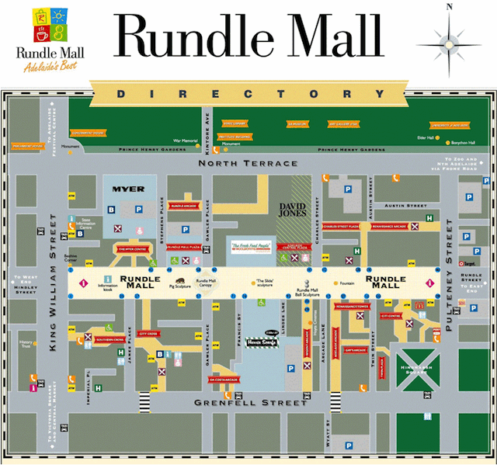  Who agrees? Brennan dissented.

